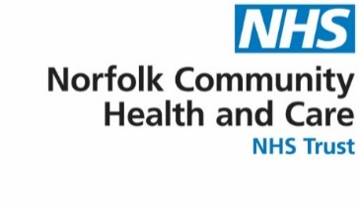

Complex Neurological Rehabilitation Outpatient Service
LOOKING AFTER YOU LOCALLY
A guide for patients and carers

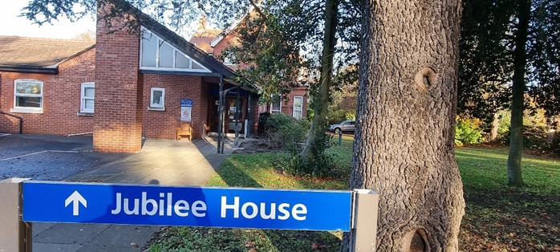

Welcome
The Colman Centre for Specialist Rehabilitation Services (CCSRS) is at:
Jubilee House
Colman Hospital
Unthank Road, Norwich NR2 2PJ.

We help people with disabilities as a result of conditions such as:
- acquired brain injury
- spinal injuries
- neuromuscular disorders

and whose needs cannot be met by standard community services.

If you have complex rehabilitation needs which are not neurological, clinicians will decide whether this is the right service.
We mainly see people in clinic. We may see people in other settings, including their own home if necessary.

How to access this service
Referrals to this service must be made by a healthcare
professional.
What to expect
If a referral is accepted an appointment for
assessment will be offered.
After this appointment, individuals will be told whether CCSRS is the most suitable service to support their rehabilitation.
Advice may be given on other services that can help.
The team will support you with:
-setting realistic rehabilitation goals
-providing individual programmes to meet these goals.
You may be given activities and exercises to be carried out between appointments.

The Team
Our team includes:
- Administrative staff
- Healthcare Assistants
- Nurse
- Occupational Therapists
- Clinical and Neuropsychologists
- Physiotherapists
- Rehabilitation Assistants
- Rehabilitation Consultants
- Speech and Language Therapists

You may only need support from some of the above teams

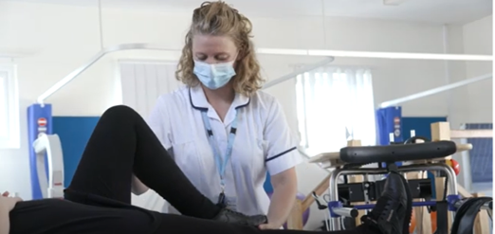

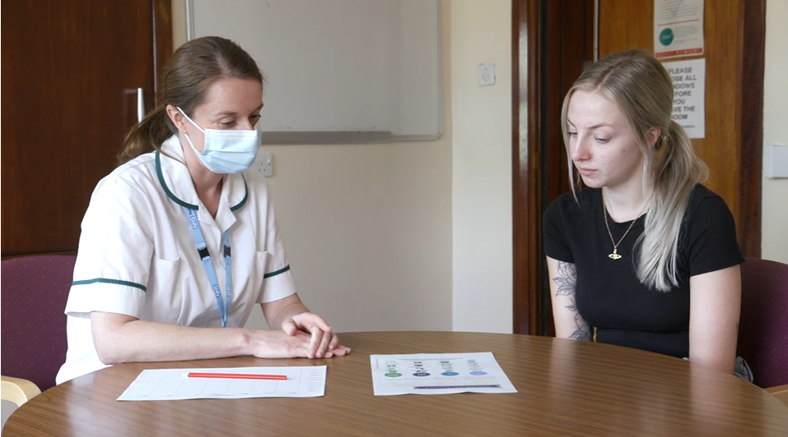

Use the link below to watch our video about services at Jubilee House, Colman hospital.

https://www.youtube.com/watch?v=yrAy8WrG470

How to get here
Patients need to make their own travel arrangements to Jubilee House.
There is some parking on-site.
You will need to enter your car registration at reception.
There is street parking nearby.

There are local bus routes.
Some patients are eligible for free, non-emergency hospital transport.
Tel: 0333 240 4100 and see www.ersmedical.co.uk for more details.
Some patients may be able to book community transport. There is a cost for this service.
Telephone: 0344 800 8020 (Monday to Friday 9am - 5pm) https://www.norfolk.gov.uk/roads-and-transport/public-transport/transport-plus.


If you would like this publication in large print, Braille, alternative format or in a different language, please contact us on 0800 088 4449 and we will do our best to help.

Feedback
You can receive help with queries about NCH&C services, or provide feedback about them, by contacting Patient Advice and Liaison Service:
Telephone: 0800 088 4449
Email: pals@nchc.nhs.uk
(Monday-Friday 9am-5pm)

You can also tell us how likely you are to recommend our service to friends and family if they needed similar care of treatment. Hearing your views helps our staff understand what they are doing well, and where improvements can be made.

Ask a member of staff for a Friends and Family form or visit:
www.nchc.nhs.uk/patientfeedback

Produced by Norfolk Community Health and Care NHS Trust
month year
Leaflet review date
month year
Version
Version

