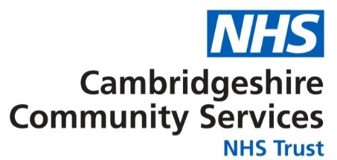
Privacy notice
Your privacy matters to us. We know you share very sensitive information with us, so it is important that we are open and held to account for how we hold and use it.
We collect a lot of different information about you to make sure we are giving you the right care. This might include:
- Your name
- Where you live
- Your phone number
- Your birthday
- Your test results
- X-rays and scans
- Any medications you take
- Notes from your appointments
- Photos or videos taken as part of your care
- Personal information like your race, religion or sexuality
- Information from people who care for you and know you well, such as health professionals and your family
Together this information helps us understand your health and how we can help you.
This information may also be used to:
- Support other health and social care services
- Plan future care
- Support public health
- Protect vulnerable people
- Train new health workers
- Check against the information held about you by other NHS systems
- For research
- Check how we are spending our money.
Where possible we do that anonymously.
Whenever your data is moved or stored, we make sure it is safe by using trusted systems and companies.
Some of your information may be held on paper and some may be electronically. Access is restricted to those who need to know.
Laws cover everyone who works for us to make sure we protect your information. They all have training every year on protecting your data, keeping things confidential and protecting information when from hacking and other cyber-crimes.
Sometimes we will need to share your data with others. We only do this where it is the best thing for you, or where we need to share it by law. This includes your GP, council, school or hospital. We may also share with charities like Barnardo’s if you give your consent. It is not used for marketing or shared with insurance companies.
You have rights. This includes:
- To have a copy of your data
- Correct mistakes in your data
- Have your data removed when it isn’t needed anymore
- Move your data to another place (if it meets certain checks)
- Limit the use of your data
- Remove your consent at any time
- Object to the use of your data
- Complain to the Information Commissioners Office.
If you would like more information, please contact the Trust’s Data Protection Officer Monty Keuneman on ccs.accesstoinfo@nhs.net or 01480 822063.
We also have a senior person responsible for protecting your information known as the Caldicott Guardian, this is Dr David Vickers.
If you have a complaint or concern you can write to:
The Complaints Department
Freepost: RTGA-CTLG-SCKH
PALS & Patient Experience Team
3 Meadow Park
St Ives
CAMBRIDGESHIRE
PE27 4LG
Tel: 0800 013 2511
Email: ccs-tr.pals@nhs.net
If you are not happy with our response, you may wish to contact:
Information Commissioner’s Office
Wycliffe House
Water Lane
Wilmslow
Cheshire
SK9 5AF
Their web site is at www.ico.gov.uk

Useful links

You can find our more detailed Privacy Notice at https://www.cambscommunityservices.nhs.uk/about-us/priorities-and-how-we-are-doing/performance/information-governance/privacy-notice

Privacy Notices for all our services are available here.

CCS is also taking part in My Care Record which is a way of improving care by joining up health and care information. Find out more or to register your choice to opt out, please visit www.nhs.uk/your-nhs-data-matters You can change your mind about your choice at any time.

For more information about how your information may be used in research and your rights please visit: https://www.hra.nhs.uk/information-about-patients/

