Patient Safety Incident Response Policy v1.4
Document Type: | Policy
Document Number: | 732
Document Owner: | Chief Nurse
Document Service: | Corporate
Medicines: | Chief Pharmacist
Scope: | This policy is specific to patient safety incident responses conducted solely for the purpose of learning and improvement across the services that we provide.  Response types that are outside the scope of this plan include those resulting from:  - Complaints  - Human resources investigations  - Professional standards investigations  - Coronial inquests  - Criminal investigations  - Claims management  - Financial investigations and audits  - Safeguarding concerns  - Information governance concerns  - Estates and facilities issues
Standards and legislation & key related documents: | It is the responsibility of the relevant staff groups to act in accordance with this policy. Key related documents include:  - Complaints Concerns and Compliments (Patient Experience)  - Supporting Staff Involved in an Incident or Complaint.  - Being Open and Duty of Candour  - Patient Safety Incident Response Plan  - Incident Review Process SOP  - Freedom to Speak Up Policy 7.0  - Reward and Recognition for Involvement Partners V2.1
Approved by: | Quality Improvement & Safety Committee
Date approved: | May 2025 | Expiry date: | April 2026
Financial Implications: | Where a document has any financial implications on the Trust, the Local Counter Fraud Specialist (LCFS) has the authority to investigate and challenge this document in regards to current fraud and bribery legislation and to ensure appropriate counter fraud measures are in place. LCFS contact details are available on the Trust’s Intranet.
Equality Impact Assessment (Policies only): | The author has carried out an Equality Impact Assessment (EIA) and, there are no negative impacts. The form is attached to this document.
Trust Values | This policy has been developed to ensure it aligns with our Trust values of honesty, empathy, ambition, and respect.
Diversity & Inclusion Statement | Cambridgeshire Community Services NHS Trust will ensure that this policy is applied in a fair and reasonable manner that does not discriminate on such grounds as age, disability, gender reassignment, marriage and civil partnership, pregnancy and maternity, race, religion and belief, sex & sexual orientation.
Keywords: | PSIRF, patient safety, patient safety incident response policy
This is a controlled document. Whilst it may be printed, the electronic version on the Trust’s Intranet is the controlled copy. Any printed copies are not controlled.

VERSION CONTROL SUMMARY
Version: | Page or section: | Description of change: | Date approved:
1.0 | N/A | First issue
1.1 | Page 6 and 17  Page 12  Page 17  Pages 18-19 | Update about Patient Safety Specialist, inclusion of job description in Appendix 1  Update to local review terminology  Inclusion of Quality Improvement Group in monitoring  Addition of Appendices detailing guidance for reviewers and for supporting staff
1.2 | Page 14 | Cropped image formatted.
1.3 | All | Review date extended from April 2025 to April 2026 | May 2025
1.4 | Section 14 | Addition of the “Being Fair” tool | July 2025

TABLE OF CONTENTS PAGE
1.0 | Introduction | 5
2.0 | Objectives | 5
3.0 | Duties, Roles & Responsibilities | 5
4.0 | Training & Competency | 7
5.0 | Our Patient Safety Culture | 8
6.0 | Duty of Candour | 9
7.0 | Addressing Health Inequalities | 9
8.0 | Engaging and Involving Patients, Families and Staff Following a Patient Safety Event | 10
9.0 | Patient Safety Incident Response Planning | 10
10.0 | Our Patient Safety Incident Response Plan | 10
11.0 | Reviewing Our Patient Safety Incident Response Policy and Plan | 10
12.0 | Responding to Patient Safety Incidents | 11
13.0 | Timeframes for Learning Responses | 13
14.0 | Being Fair Tool: Supporting Staff Following a Patient Safety Incident | 14
15.0 | Safety Action Development and Monitoring Improvement | 14
16.0 | Safety Improvement Plans | 15
17.0 | Complaints and Appeals | 15
18.0 | Structure for Local Incident Reviews and Governance | 16
19.0 | Monitoring & Audit | 17
 | Appendix 1: Patient Safety Specialist Job Description | 18
 | Appendix 2: Guidance for the support process | 19
 | Appendix 3: Guidance for the process of involvement, engagement and support | 20
 | Appendix 4: Guidance for reviewers talking to Service Users | 21
 | Appendix 5: Guidance for reviewers talking to Staff | 22

1.0 | INTRODUCTION
1.1 | The Patient Safety Incident Response Framework (PSIRF) promotes a co-ordinated and data-driven response to patient safety incidents. It embeds the process of patient safety incident response within a wider system of quality improvement and prompts a significant cultural shift towards patient safety management for the purpose of learning and improvement.  This policy supports the development and maintenance of an effective patient safety incident response system that integrates the four key aims of the PSIRF and supports a just and learning culture:  - compassionate engagement and involvement of those affected by patient safety incidents (PSIs),  - application of a range of system-based approaches to learning from PSIs,  - considered and proportionate responses to PSIs and safety issues,  - supportive oversight focused on strengthening responses and improvement.
2.0 | OBJECTIVES
2.1 | This policy supports the requirements of the PSIRF. It sets out our approach for responding to patient safety incidents and issues.  Responses under this policy follow a systems-based approach, recognising that safety is provided by interactions between and not solely from a single source, and that learning does not take a ‘person-focused’ approach where the actions or inactions of people, or ‘human error’, are stated as the cause.  The principle aims of other processes such as claims handling, human resources investigations into employment concerns, professional standards investigations, coronial inquests and criminal investigations differ from those of a patient safety response and are outside the scope of this policy. Information from patient safety review processes can be shared with those leading other types of learning responses but should not influence the remit of a patient safety incident response.
3.0 | DUTIES, ROLES & RESPONSIBILITIES
3.1 | Chief Executive and Board of Directors  Our principal accountability is to patients / service users and their families / carers. In the fulfilment of our duty in this regard, the Board has ensured that an appropriate incident management system is in place for the reporting and monitoring of incidents, for effective governance and learning through assurance of our patient safety incident response plan. The Board also takes responsibility for leading and role modelling the development of a just, open and learning culture.  The Chief Executive is accountable and responsible to the Board for ensuring that resources, policies, and procedures are in place to ensure the effective reporting, recording, review and treatment of incidents. They have overall responsibility for ensuring there are processes that support an appropriate response to patient safety incidents, the development of a patient safety reporting, learning and improvement system and that systems and processes are adequately resourced.
3.2 | Chief Nurse and Medical Director  - The Chief Nurse is our nominated lead responsible for ensuring we have appropriate arrangements in place for the management of incident / patient safety event reporting and associated reviews or learning responses.  - The Medical Director is our lead in the formation and implementation of clinical strategy, taking a lead on clinical standards in relation to the quality and safety of care, and providing clinical advice to the Board.  - The responsibility for defining and verifying an adverse event as a Patient Safety Incident Investigation (PSII) rests with either our Chief Nurse or Medical Director (or a nominated delegate in their absence) as part of the patient safety incident response plan. Once verified, they will ensure the appropriate internal and external reporting is carried out and the review or learning response commences in accordance with this policy.
3.3 | Service Directors and the Executive Team  - All Service Directors are responsible for ensuring incident reporting arrangements, as described in this policy, are implemented throughout their service areas, for the implementation of Duty of Candour, actions and dissemination of learning following patient safety incidents.
3.4 | Deputy Chief Nurse and Patient Safety Specialists  - The role of the Patient Safety Specialist (PSS) will be jointly undertaken by the Deputy Chief Nurse, Assistant Director for Professional Practice (Nursing) and the Clinical Quality Manager, who together will meet the requirements of the role as outlined in the national job description (see Appendix 1).  - The Deputy Chief Nurse and PSS’ will be responsible (on behalf of the Chief Nurse and the Medical Director) for overseeing the development and review of the patient safety incident response plan, ensuring that PSIIs are undertaken for all incidents that require it (as directed by our patient safety incident response plan) and that there are sufficient resources to support delivery (including support for those affected, such as named contacts for staff, patients / service users, families and carers where required).  - They are also responsible for ensuring that there are processes that support an appropriate response to patient safety incidents (including contribution to cross-system / multi-agency reviews and / or investigation where required), that the executive and non-executive team can access relevant safety incidents including the impact of changes following incidents, and that processes for preparing for and responding to patient safety incidents are reviewed as part of overarching governance arrangements.  - The Deputy Chief Nurse and PSS’ will meet these duties through delegated responsibility to the Quality team.
3.5 | Service leads / Managers will:  - Ensure that incidents are reported and managed in line with internal and external requirements.  - Ensure that they and their staff are familiar with the PSIRF, patient safety incident response plan and policy and support the development and delivery of actions in response to patient safety reviews / PSIIs that relate to their area of responsibility.  - Provide protected time for participation in learning responses / PSIIs as required.  - Work with teams to ensure those affected by patient safety incidents have access to the support they need.
3.6 | Learning response leads  - Learning responses will be led by learning response leads who have experience and training in conducting patient safety incident responses and in the involvement and engagement of those affected.
3.7 | Patient Safety Partners  The NHS Patient Safety Strategy promotes the involvement of patients / service users, families, and carers as partners both in their own care and in the wider oversight of healthcare. Our Patient Safety Partners are supported by a named individual in the Trust, access regular supervision and have been involved in the development of our patient safety incident response policy and plan. They support the voices of services users to be heard at all levels of the organisation through:  - membership of safety and quality committees whose responsibilities include the review and analysis of safety data,  - involvement in patient safety improvement projects,  - working with teams and services to consider how to improve safety,  - involvement in relevant staff patient safety training,  - participation in investigation oversight groups where appropriate,  - participation in projects that focus on learning and involvement  - where appropriate, Patient Safety Partners may work across the Integrated Care System and participate in local system Patient Safety Partner networks / Communities of Practice as required and relevant.
3.8 | All staff will:  - Understand their responsibilities in relation to the patient safety incident response plan, policy and PSIRF and act accordingly.
4.0 | TRAINING & COMPETENCY
4.1 | Learning Response Training  Learning response leads will have completed level 1 (essentials of patient safety), and level 2 (access to practice) of the patient safety syllabus in addition to undertaking continuous professional development in incident response skills and knowledge, and at least two days’ formal training and skills development in learning from patient safety incidents / safety events. They will contribute to a minimum of two learning responses per year.  All our staff leading learning responses will be able to:  - Apply human factors and systems thinking principles to gather qualitative and quantitative information from a wide range of sources.  - Summarise and present complex information in a clear and logical manner and in report form.  - Manage conflicting information from different internal and external sources.  - Communicate highly complex matters and in difficult situations.
4.2 | Engagement and Involvement Training  Engagement and involvement with those affected by patient safety incidents will be led by learning response leads who will have had at least six hours of training in involvement and engagement.  In addition, competencies and behaviours include:  - Communicating and engaging with patients / service users, families, staff, and external agencies in a positive and compassionate way.  - Listening and hearing the distress of others in a measured and supportive way.  - Maintaining clear records of information gathered and contact with those affected.  - Identifying key risks and issues that may affect the involvement of patients / service users, families, and staff.  - Recognising when those affected by patient safety incidents require onward signposting or referral to support services.
4.3 | Oversight training  All patient safety incident response oversight is led / conducted by those with at least two days formal training and skills development in learning from patient safety incidents, and one day training in oversight of these.
5.0 | OUR PATIENT SAFETY CULTURE
5.1 | This section should be read alongside the Supporting Staff Involved in an Incident or Complaint policy.  The following principles underpin our oversight of patient safety incident responses:  - Improvement is the focus  - Blame restricts insight  - Learning from patient safety incidents is a proactive step towards improvement  - Collaboration is key  - Psychological safety allows learning to occur  - Curiosity is powerful  Our PSIRF strives to be a framework that supports the development and implementation of an effective patient safety incident response system that supports system-based learning and takes a proportionate approach.  This system-based approach takes into account all of the interactions that may contribute to a patient safety event (e.g., person(s), tasks, equipment and technology, the environment, the wider organisation etc.) and recognises that it is insufficient to look at only one element, such as the people involved. A system-based approach will identify where changes need to be made and then monitor these to improve patient safety.  Using these principles, we will continue to foster open and transparent reporting reflective of a just and learning culture. Service users, carers, families and staff are encouraged to share feedback, raise concerns, compliment, highlight good practice and if needed, supported to make a complaint through well-established channels such as:  - Friends and Family Test surveys  - Access to the Patient Advice and Liaison team  - Freedom to Speak up Champions and the Trust Freedom to Speak up Guardian  - Access to and advice from the Human Resources and Workforce team  - Support from union representatives
6.0 | DUTY OF CANDOUR
 | Keeping our service users safe is a responsibility we all hold and so we strive every day to ensure that we cause no harm. All trust employees work hard to provide services which are safe and of a high quality; however, it is a fact that despite this, sometimes things can and do go wrong and incidents will occur. When this happens, we will respond quickly and positively to ensure the wellbeing of the people who use our services and our employees. The Being Open and Duty of Candour policy provides guidance for staff on the processes and steps to follow in supporting patients and carers following an incident meeting the requirements for the provision of Duty of Candour. It sets out specific requirements to follow when things go wrong with care and treatment, including informing people about the incident, providing reasonable support, providing truthful information and an apology.
7.0 | ADDRESSING HEALTH INEQUALITIES
7.1 | Some services users may be less safe than others in healthcare settings. The PSIRF provides a mechanism to try to address these unfair and avoidable differences. The more flexible approach of PSIRF makes it easier to address concerns specific to health inequalities and provides the opportunity to learn from patient safety incidents that would not have met the definition of a ‘Serious Incident’ under the previous framework.  PSIRF also endorses a system-based approach that supports the development of a just and learning culture that reduces the inequality gap in rates of disciplinary action across our workforce.  Our incident response processes support health equality reduction by:  - Applying a more flexible approach and intelligent use of data to help identify any disproportionate risk to patients / service users with specific characteristics which can then inform patient safety incident responses.  - Exploring and responding to issues related to health inequalities as part of the development and maintenance of our patient safety incident response policy and plans.  - Using tools in the response of patient safety incidents to prompt consideration of inequalities, including when developing safety actions.  - Engaging and involving patients / service users, families and staff following a patient safety incident with consideration of their varied needs.  Key pieces of work underway include collecting demographic details of service users who provide feedback and are involved in complaints and incidents, and better understanding and increasing the diversity of people who are involved in our participation approach; these aims tie into our strategic vision.
8.0 | ENGAGING AND INVOLVING PATIENTS, FAMILIES AND STAFF FOLLOWING A PATIENT SAFETY INCIDENT
8.1 | The PSIRF recognises that learning and improvement following a patient safety incident can only be achieved if supportive systems and processes are in place. It supports the development of an effective patient safety incident response system that prioritises compassionate engagement and involvement of those affected by patient safety incidents (including patients / service users, families and staff).  This involves working with those affected by patient safety incidents to understand and answer any questions they have in relation to the incident and signpost them to support as required, as well as ensure that Duty of Candour is upheld.
9.0 | PATIENT SAFETY INCIDENT RESPONSE PLANNING
9.1 | We will use the PSIRF to respond to patient safety incidents and safety issues in a way that maximises learning and improvement, rather than basing responses on arbitrary and subjective definitions of harm. Beyond the nationally set requirements, we have completed a review over 3 years of our incidents and complaints and asked our staff about patient safety incidents. These have informed our patient safety incident response plan.
10.0 | OUR PATIENT SAFETY INCIDIENT RESPONSE PLAN
10.1 | Our Patient Safety Incident Response plan sets out how we intend to respond to patient safety incidents over a period of 18 months, commencing September 2023. The plan is not a permanent set of rules and we will remain flexible and consider the specific circumstances in which each patient safety incident occurred and the needs of those affected. This policy should be read alongside the Patient Safety Incident Response Plan.
11.0 | REVIEWING OUR PATIENT SAFETY INCIDENT RESPONSE POLICY AND PLAN
11.1 | Our patient safety incident response plan is a ‘living document’ that will be appropriately amended and updated as we use it to respond to patient safety incidents. We will review the plan in 18 months commencing from September 2023, to ensure our focus remains up to date; with ongoing improvement work our patient safety incident profile is likely to change. This will also provide an opportunity to re-engage with stakeholders to discuss and agree any changes needed.  Updated plans will be published on our website, replacing any previous version.  A rigorous planning exercise will be undertaken every three years (and more frequently if appropriate, as agreed with our Integrated Care Boards) to ensure efforts continue to be balanced between learning and improvement. This more in-depth review may include reviewing our response capacity, mapping our services, a wide review of organisational data (for example, PSII reports, improvement plans, complaints, claims, staff survey results, inequalities data, reporting data etc) and wider stakeholder engagement.
12.0 | RESPONDING TO PATIENT SAFETY INCIDENTS
12.1 | Patient safety incident reporting arrangements  All PSIs must be reported through LFPSE (Learning From Patient Safety Event), using the approved processes to ensure their appropriate reporting and handling. We will continue to work with all statutory bodies, such as the police, and ensure that all statutory reporting is completed, e.g., to the Health and Safety Executive (HSE) and the Medicines & Healthcare Products Regulatory Agency (MHRA) where needed. The processes contained within this document do not supersede the normal legal requirements to notify other agencies when required.  We will also continue to work with organisations and co-operate with any learning responses that cross organisational boundaries.  As part of incident reporting, all staff are required to:  - Report all incidents, patient safety events and near misses via the electronic incident management system, Datix.  - Ensure the details of any incidents / patient safety events are contemporaneously and objectively reported in the patient / service user’s clinical record.  - Raise any concerns about situations that led to, or could lead to, an incident, patient safety events or a near miss with their line manager or the Quality Team.  - Actively participate in any subsequent reviews or learning responses, providing an account, attending multidisciplinary fact-finding and feedback meetings etc as needed.  - Attend a Coroner’s inquest if called to do so.  - Undertake mandatory training in the reporting of incidents / patient safety events.  - Undertake additional training, as required, to ensure competence in relation to the Datix system.  Further details of incident reporting arrangements are detailed in the Incident Review Process SOP.  We will make available appropriate support to those staff involved in an incident / patient safety event, where this is required (see also Our Safety Culture section).  A member of staff may also raise a concern at any time either verbally or in writing (see also Freedom to Speak Up Policy 7.0)
12.2 | Patient safety incident response decision-making  Patient safety incidents will be responded to with due regard to our patient safety incident response plan. We will respond to incidents in a way that maximises learning and improvement and will explore patient safety incidents relevant to the context of our organisation and the populations we serve, rather than exploring only those that meet a certain nationally defined threshold.  Responding proportionately to balance learning and improvement will require a thorough understanding of the local patient safety incident profile and ongoing improvement work. We will use a SEIPS (System Engineering Initiative for Patient Safety), or similar systems-based framework with knowledge of human factors science alongside advocacy of a just and learning culture, to understand outcomes within complex systems for the purpose of learning.  Planning will support proactive allocation of patient safety incident response resources, as well as consideration that there will need to be a reactive element in responding to incidents. A response will always be considered for PSIs that signify an unexpected level of risk and / or where the potential for learning and improvement is great, but would otherwise fall outside the issues or specific incidents described in our patient safety incident response plan.  Emergent issues not included in the patient safety incident response plan will be identified through monthly meetings where multiple sources of data, including insight from complaints and incidents, is triangulated to look for emerging themes and trends. Any resources needed to support responses to these will be allocated through the Quality team and as part of the Quality Improvement strategy.
12.3 | Patient Safety Incidents Requiring a Learning Response  The PSIRF discusses 4 response types in general to patient safety incidents:  - Patient Safety Incident Investigation (PSII)  - Multi-Disciplinary Team review (MDT), referred to locally by the Trust as a Multi-Incident Review  - Swarm huddle (locally referred to as a Hot debrief / review or local review)  - After Action Review (AAR)  Patient safety incidents resulting in significant harm must be reported via the LFPSE and to notifiable partner organisations. As a minimum, PSIs (under our care) leading to unexpected death or severe harm will warrant a PSII. ‘Near misses’ and ‘no harm’ patient safety events may also warrant a learning response where the contributory causes are serious and under different circumstances could have led to serious injury, major permanent harm, or unexpected death.  Each PSI will be considered on an individual basis and the decision as to whether it meets the criteria for a learning response (and what type) will be taken by a group of subject experts to include the Quality Team, service representatives and subject matter experts. To help with the decision-making process, wherever possible, the following documents will be reviewed:  - Datix incident report  - Chronology of events  - 1st hand accounts  All decisions, including rationale of outcome, will be minuted, approved by the Chair (a senior member of the panel) and filed on the relevant Datix record, together with all other supporting documents.
12.4 | Responding to cross-system incidents / issues  We recognise that PSIs can often be complex and involve a number of organisations. Where multiple organisations need to be involved in a single learning response, support to facilitate cross-system learning responses will be provided by the Integrated Care Systems we work within. The PSII will be led by the organisation best placed to investigate the concerns and may depend on capability, capacity, or remit.  Should we be asked to contribute to other organisations’ PSIIs, there will be appropriate documentation and oversight of this and the learning. The final draft report will be shared internally and approved prior to external submission, together with approval of any learning recommendations and actions that will feed into improvement plans.  Should we need to lead on a PSII and include other organisations, representatives will be invited to initial meetings to contribute, support and understand the scope of the PSII, and clear timeframes for actions will be agreed.  As well as the Integrated Care System, other organisations that can support with the management of a PSII include NHS England and NHS Improvement and The Care Quality Commission (CQC). The Deputy Chief Nurse will ensure the appropriate notifications have been made through the LFPSE, to the Integrated Care System, Commissioner, NHS England and NHS Improvement and the CQC via delegated responsibility within the Quality team, including providing an update with the initial report at day 3 and the final PSII. The involvement of these organisations will also be considered as part of any learning response, if appropriate.
13.0 | TIMEFRAMES FOR LEARNING RESPONSES
13.1 | A response will start as soon as possible after an incident is identified and will be completed within one to three months, and within a maximum of 6 months.  The timeframe for completing a PSII will be agreed with those affected by the incident as part of setting the terms of reference, provided they are willing and able to be involved in that decision.  PSIIs (and other local responses) will take no longer than three months; however in exceptional circumstances (e.g. when a partner organisation requests an investigation is paused), a longer timeframe may be needed to respond to an incident. In this case, any extension to timescales will be agreed with those affected (including the patient / service users, family, carer, and staff).  The time needed to conduct a response must be balanced against the impact of long timescales on those affected by the incident, the risk that for as long as findings are not described actions or checks may not be taken. Where external bodies (or those affected by patient safety incidents) cannot provide information, to enable timely completion the local response leads will work with all the information they have to complete the response to the best of their ability; it may be revisited later, should new information indicate the need for further investigative activity.
14.0 | BEING FAIR TOOL: SUPPORTING STAFF FOLLOWING A PATIENT SAFETY INCIDENT
14.1 | Patient safety incidents are usually signs of underlying systemic issues that require wider system-level action. Action singling out an individual is rarely appropriate. By treating staff fairly, the NHS can foster a culture of openness, equity and learning where staff feel confident to speak up when things go wrong. Supporting staff to be open about mistakes allows valuable lessons to be learnt and prevents errors from being repeated.  However, in rare circumstances a learning response may raise concerns about an individual’s conduct or fitness to practise. It is in these specific circumstances that the being fair decision-making tool can help decide what next steps to take.
15.0 | SAFETY ACTION DEVELOPMENT AND MONITORING IMPROVEMENT
15.1 | As a Trust we will use the information from good practice and patient safety incidents to tell a story around Quality Improvement and it’s impact on patient safety. Safety action development and monitoring improvement will take place as part of our approach to continuous Quality Improvement, summarised in the infographic below. The safety action development process that follows the identification of areas for improvement is cyclical and evolving in nature and will help inform the development of safety actions. Collaboration with relevant teams will occur throughout the process.  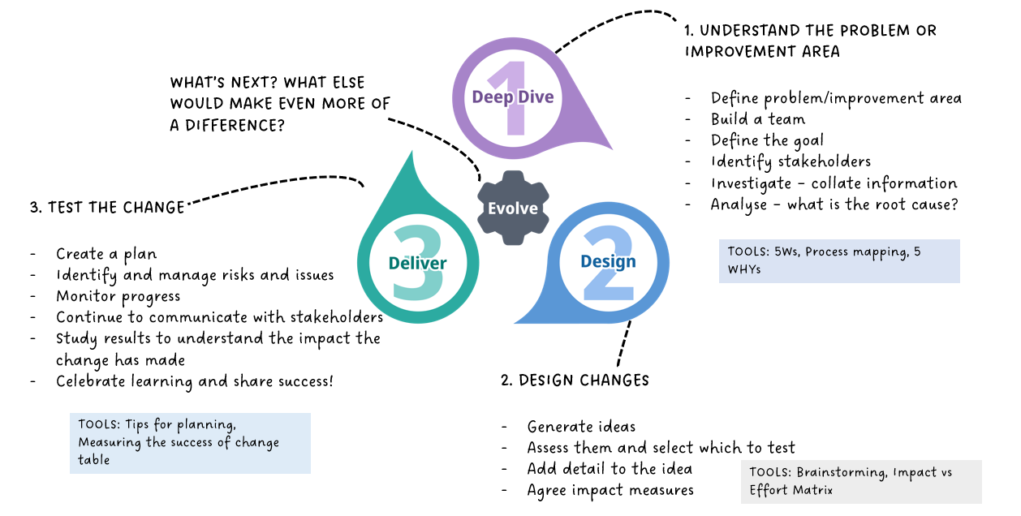  In order to monitor and review safety actions, there will be continued curiosity to inquire about how things are working and review the impact of safety actions put in place, as part of a continuous cycle of Quality Improvement.  The safety actions and associated measure(s) will be appropriately reviewed to ensure they continue to be relevant and the issues of most concern. As part of this process, we will document, record and review safety action progress and impact through governance groups and links to Quality Improvement, which may involve monitoring by a specific service area or through wider action oversight groups.  Reviews will be carried out periodically (typically annually) or when substantial changes are made.
16.0 | SAFETY IMPROVEMENT PLANS
16.1 | Robust findings from investigations and reviews will provide key insights and learning opportunities, but they are not the end of the story. Safety improvement plans will bring together findings from learning responses to patient safety incidents and issues so that these can be translated into effective improvement plans and implementation.  These plans take different forms, including:  - creating an organisation-wide safety improvement plan summarising improvement work,  - creating individual safety improvement plans that focus on a specific service, pathway or location,  - collectively reviewing output from learning responses to single incidents when it is felt that there is sufficient understanding of the underlying issues,  - creating a safety improvement plan to tackle broad areas for improvement.  All safety actions will be developed with relevant stakeholders including those responsible for implementation. The implementation and effectiveness of all safety actions are monitored, and a named individual is identified with responsibility for this.
17.0 | COMPLAINTS AND APPEALS
17.1 | This section should be read alongside the Complaints Concerns and Compliments (Patient Experience) policy.  Local arrangements for complaints and appeals relating to our response to patient safety incidents are as follows:  - Our complaints process allows for patients / service users, their carers, relatives or friends to raise concerns regarding their care and treatment. Concerns are raised via PALS or through formal Complaint. The Quality team will work closely to ensure there are effective approaches in response to patient safety incidents.  - Patient Advice and Liaison Services (PALS) offer patients / service users, families and carers confidential advice, support and information on health-related matters. As well as informally helping to resolve issues, PALS supports with filing a formal complaint and provides advice on accessing advocacy services.  - The NHS website gives guidance on how to make a complaint about any aspect of NHS care, treatment or service and details of local advocacy providers. The independent NHS Complaints Advocacy Service can also provide someone to help navigate the NHS complaints system, attend meetings and review information given during the complaints process. In addition, Local Healthwatch provides information about making a complaint, including sample letters.  - The Parliamentary and Health Service Ombudsman makes the final decisions on complaints patients / service users, families and carers deem not to have been resolved fairly by the NHS in England, government departments and other public organisations.
18.0 | STRUCTURE FOR LOCAL INCIDENT REVIEWS AND GOVERNANCE
18.1 | The structure, processes and governance for local incident meetings are detailed below and in more detail in the Incident Review Process SOP. Learning will feed into the Quality Improvement & Safety Committee (QISCOM) and up to Board.  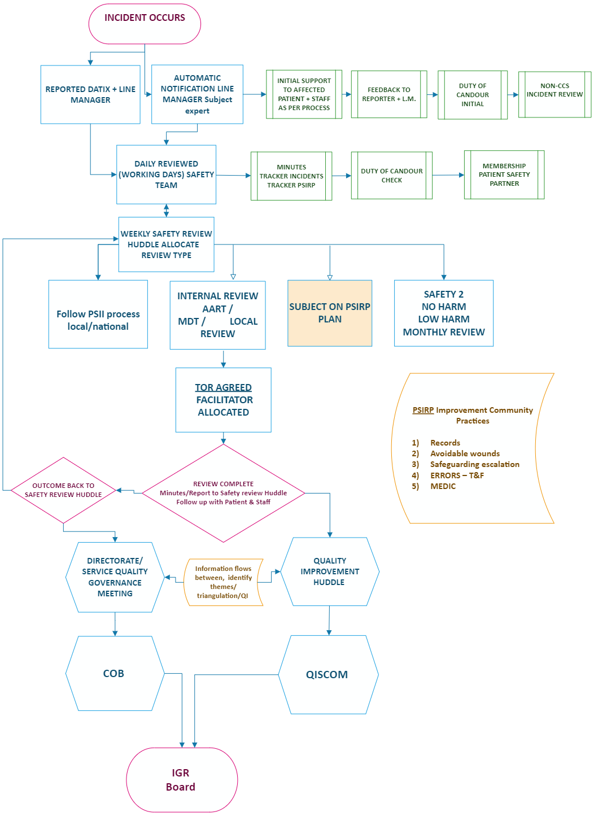
19.0 | MONITORING & AUDIT
18.1 | There is a robust system of reporting, oversight and governance in place supporting the adoption of a proactive approach to the identification and management of incidents and any potential gaps.  - Reports are provided to the Quality Improvement Group and Quality Improvement & Safety Committee (QISCOM) as per the annual reporting schedule.  - The safety actions and associated measure(s) will be appropriately reviewed to ensure they continue to be relevant and the issues of most concern. As part of this process, there will be documentation, recording and reviews of progress against actions and impact through governance groups and links to Quality Improvement, which may involve monitoring by a specific service area or through wider action oversight groups.
 | APPENDIX 1
 | Patient Safety Specialist job requirements

Appendix 2: Guidance for the support process
- Actions / learning feed into improvement plans / workstreams and are disseminated as appropriate
- Restorative approach for patient / staff / service continues as needed

- Reviewer initiates contact with staff member and follows guidance for the review process
- Datix completed, review initiated, and Duty of Candour completed if required

- Incident or complaint occurs
- Line manager explores any immediate support needs for their staff and clearly documents this
- Line manager assesses the requirement to contact HR to identify any additional staff support required
IMMEDIATE SUPPORT
CONTINUED SUPPORT
ONGOING SUPPORT

- Line manager informs staff member that a review is being initiated, checks in with staff member about how they are feeling and re-explores support, (including any peer support available)
- Line manager links in with reviewer (and HR if appropriate)

- Reviewer informs staff member that the process has ended, discusses any new support needs that may have emerged and informs line manager
- Line manager updates staff member and explores any additional support needs

Guiding principles for engagement and involvement
• Apologies are meaningful • Approach is individualised, collaborative and open • Timing is sensitive • Everyone is treated with respect and compassion • Expectations are addressed • Guidance and clarity are provided • People are ‘heard’ • Subjectivity is accepted • Strive for equity

Appendix 3: Guidance for the process of involvement, engagement and support
Patient Safety Incident (PSI)
Staff member / line manager completes Datix and initiates Duty of Candour
Subject matter experts meet to discuss PSI and agree learning response type
Reviewer / clinical team / subject matter experts agree who will be involved to best act as the service user voice (e.g., service user / family / representative)
Learning response lead initiates contact with service user / family / representative and follows guidance for initial contact
Line manager informs staff member that a learning response is being initiated, checks in with staff member, offers support and signposts to resources
Learning response lead follows process for ongoing contact
Learning response lead informs line manager and individuals that the process has ended and follows guidance for closing contact
Learning response lead contacts staff member and follows guidance for initial contact. Checks in with line manager regarding any identified support needs
Terms of Reference set
Actions / learning feed into improvement plans and are disseminated as appropriate
Clinical team to explore any immediate support needs for the patient, family, and staff members
Restorative approach for patient / staff / service continues as required
Evaluation process for measuring the quality of the response and engagement / involvement

Guiding principles for engagement and involvement
• Apologies are meaningful • Approach is individualised, collaborative and open • Timing is sensitive • Everyone is treated with respect and compassion • Expectations are addressed • Guidance and clarity are provided • People are ‘heard’ • Subjectivity is accepted • Strive for equity
Appendix 4: Guidance for reviewers talking to Service Users
Terms of Reference
- Explain what the term “terms of reference” (ToR) means
- Discuss how the ToR were decided
- Explains what they are addressing
- Explore additional ToR from the individual
- Explore any questions or queries from the individual

Sharing experiences
- Explore whether the person needs someone with them for support
- Explore how the person would like to share their experience
- Discuss who else will / has shared their experience as part of the process
- Discuss how the information will be used

Receiving drafts (if applicable)
- Explore how the person wants to receive the information
- Discuss how the person can provide comment
- Discuss how their comments might be used
- Discuss what happens between the draft and the final report / record

ONGOING CONTACTS
Before initiating contact
- Learning response type will have been agreed following discussion with subject matter experts
- Who will be involved to best act as the service user voice will have been agreed e.g., service user where appropriate, member of wider family or advocate (e.g., PSP)
- Have provided at least the verbal apology as a minimum response for Duty of Candour

Throughout the process
- Explore support needs and signpost to appropriate resources
- Keep to the agreed contact schedule, agree next date of contact, make note of any dates to avoid
- Explore level of involvement (more of less preferred), any alternative or augmentative language support needed and expectations
The incident and process
- Discuss why a learning response is being undertaken, what has been done, what is planned
- Address questions or queries and key points they raise
- Agree how to reference people in the review paperwork

Involvement
- Discuss the purpose and intended outcomes
- Agree level of involvement wanted:
  - Terms of reference
  - Sharing experiences
  - Findings
  - Draft / final report / record
INITIAL CONTACTS
Introductions
- Introduce self and share contact details. Set up a suitable time for initial contact meeting
- Explore any support / access needs
- Agree preferred methods of contact
- Agree frequency of contact, plan, and dates
- Discuss service user’s questions
Final report / record
- Explore in what format the individual would like the final version
- Address questions the person has, or any queries
- Discuss how the Trust will use the information

Other / further involvement
- Explore what further involvement could look like
- Explore who further involvement might be with
- Explore how long further involvement could continue
- Explore expectations

Formal end of the process
- Thank the individual for their involvement
- If they opted not to be involved, update them that the process has ended
- Discuss the Trust’s commitment to learn and improve
- Offer another meaningful apology
CLOSING CONTACTS
Appendix 5: Guidance for reviewers talking to Staff
Introductions
- Share contact details
- Explore any support identified and previous experiences
- Agree best method of contact, plan, and dates
- Discuss the aim being improvement and learning, rather than blame
- Ask staff member if they would like someone present with them
The incident
- Explain why a learning response is being undertaken
- Discuss what has been done so far, and what is planned
- Manage and address staff member’s expectations
- Address questions / queries from staff member and check understanding
The process
- Discuss the process of the learning response and where staff involvement is needed:
  - Terms of reference
  - Chronology
  - Sharing experiences
  - Meetings
  - Draft / final report / record

INITIAL CONTACTS
Before initiating contact
- Learning response will have been agreed during patient safety discussion meeting with subject matter experts
- Staff member will have been informed that a learning response is being undertaken by line manager, explaining the process is about learning and not blame
Support
- Explore with line manager what immediate support and signposting has been identified and provided
- Consider whether support needs change during the process
- Ensure language used is accessible so there is a shared understanding or what is being discussed

Terms of Reference
- Discuss what they are and how the terms of reference were decided
- Discuss what they are addressing
- Explore any questions the member of staff has

Sharing experiences
- Explore how the member of staff is feeling
- Discuss how the information will be used
- Discuss who else has / will share their experience
Receiving drafts (if applicable)
- Asks if staff member wants the draft and then arrange to discuss it in person
- Discuss how the staff member can provide comments and how their comments might be used
- Discuss what happens between the draft and final report / record
ONGOING CONTACTS
Final report / record
- Explore whether the staff member would like the final report and how
- Address questions from the staff member
- Explain how the Trust will use the information

Formal end of the process
- Thank the staff member for their involvement
- Discuss what happens next and any possible further involvement
- Reiterate the Trust’s commitment to a just and learning culture, ensuring learning and improvement rather than blame
CLOSING CONTACTS
Support
- Explore how the staff member is feeling now
- Explore if they need any support and if so, what
- Discuss how the experience has been for them
- Link with line manager regarding any support identified

