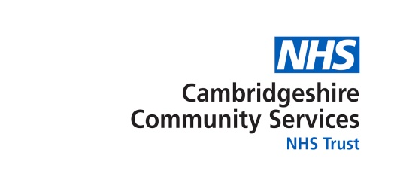
Annual Report 2023/24 - Easy read



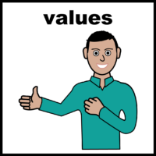

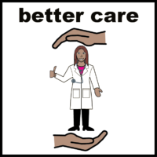
About us
We help support the health of people in their homes and in the community.
We have 2,737 staff.
We have 67 volunteers.
This report looks at what we have done in the last year and if we have done a good job.

What matters to us
We want to help people to be healthy and happy.
Our values are about being honest, kind, doing our best and showing people respect.

Our focus this year
Our focus this year has been on four areas:
- Giving outstanding care

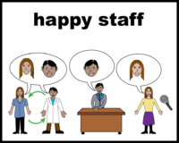

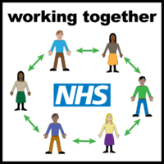

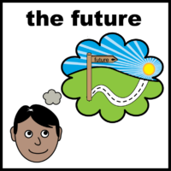

- Being an excellent place to work

- Working with others

- Thinking about the future – like looking after our money and looking after the planet

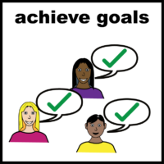

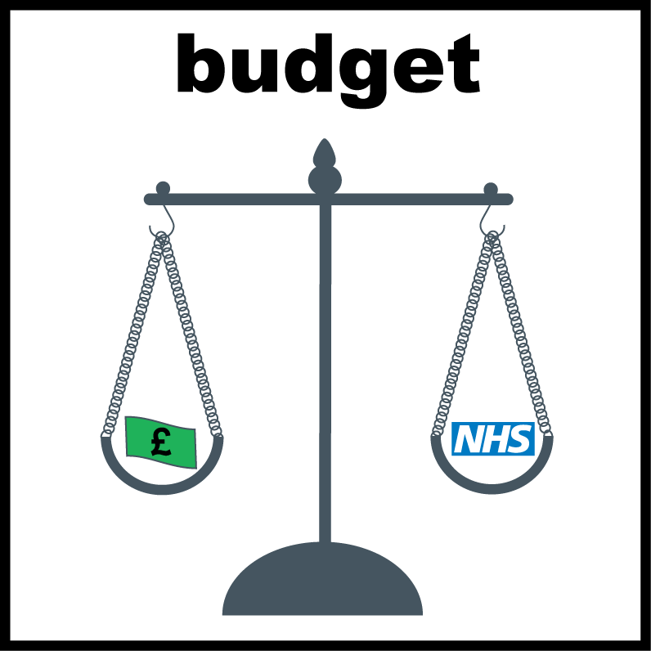

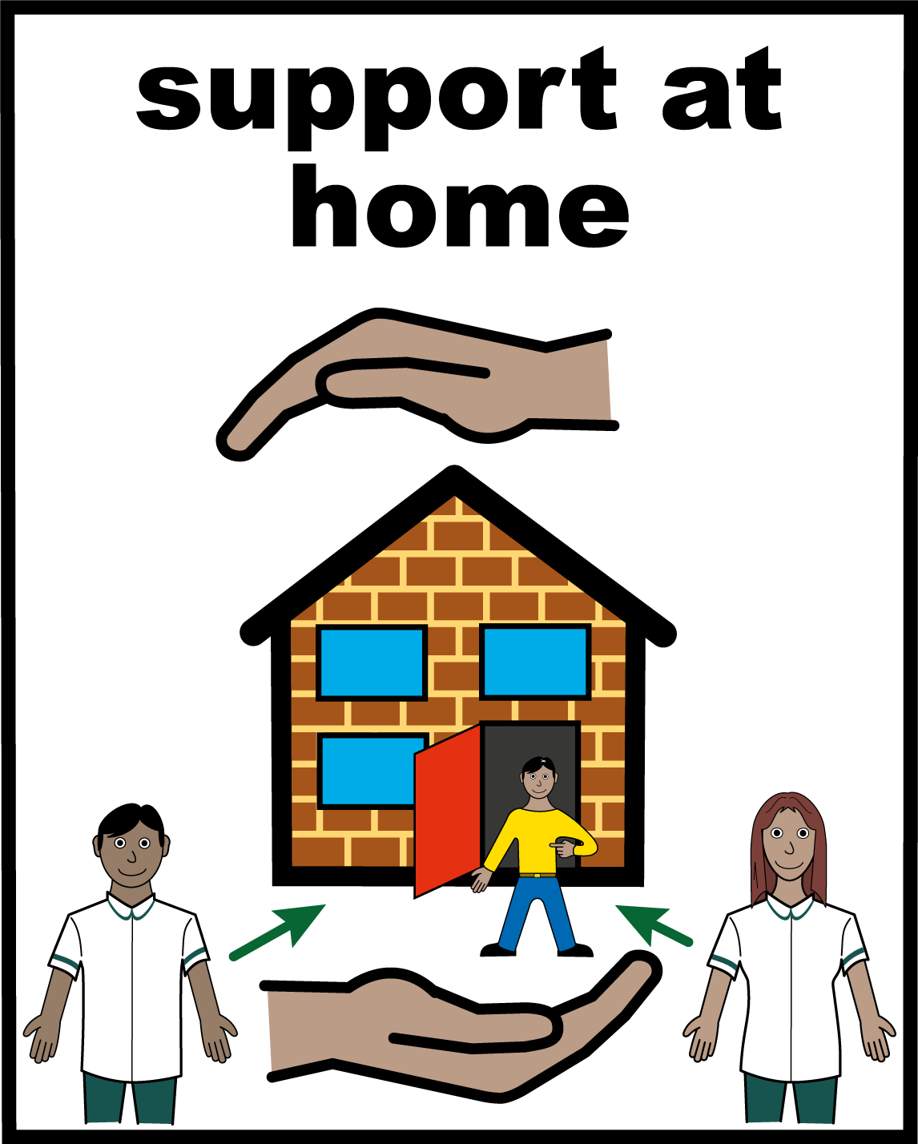

How have we done?
We have been working hard to give good care for all.

Most people who use our services say we do a good or very good job.

We have also worked to make our care better. This work has been with patients.

We have been careful with our money. We delivered all of services and had a little bit left over at the end of the year.

Bedfordshire - Our new virtual wards help people get the care they need at home and avoid hospital. This is better for patients who can stay somewhere they know and feel safe.

tests
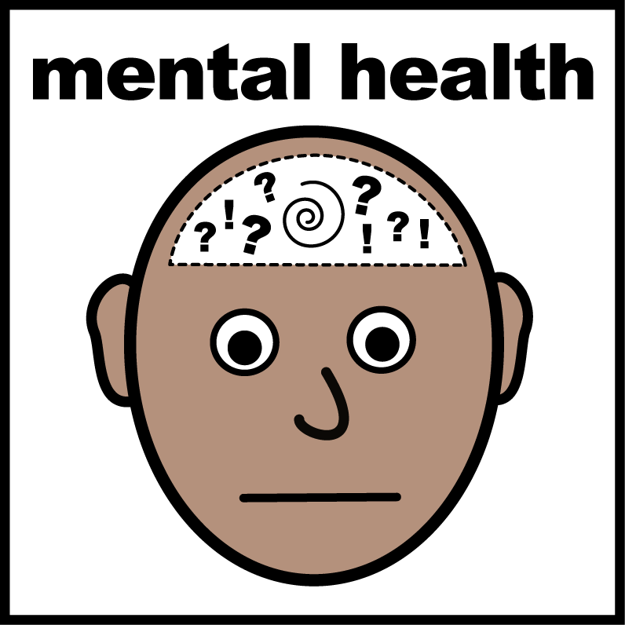

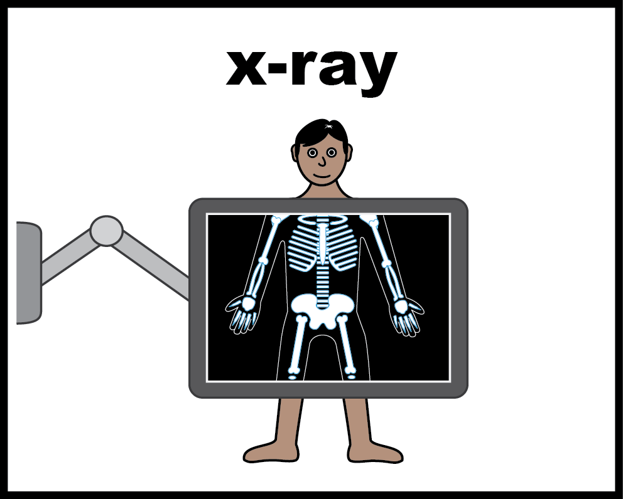

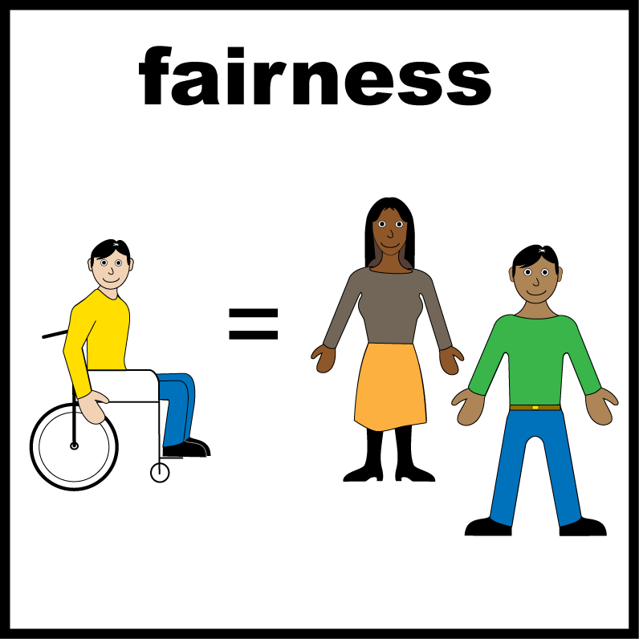

All images/resources copyright ©LYPFT

Norfolk - Our new mental health service helps direct young people and their families to the help they need.

Ely, Cambridgeshire - A new centre helps people access tests and scans closer to home. It is now easier to park at the hospital too.

We have been working to make sure services are fair for all. This includes work to help people who are disabled, neurodiverse, homeless or from different backgrounds.

