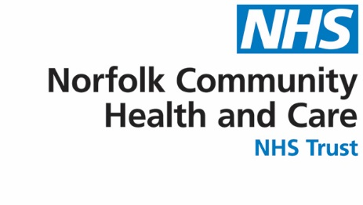
LOOKING AFTER YOU LOCALLY
West Norfolk Specialist Multidisciplinary Neurology Team
Community Neurology Service


If you would like this leaflet in large print, audio, Braille, alternative format or in a different language please contact 0800 088 4449

You can receive help with queries about NHS services from our
Patient Advice and Liaison Service

Telephone: 0800 088 4449
Email: pals@nchc.nhs.uk

Leaflet updated: Jan 2024
Leaflet review date: Jan 2025
Contact Details

Phone:
01553 668599 or 01553 668768

Email:
community.neuro@nchc.nhs.uk

Community Neurology Service

Our service provides assessment, treatment, maintenance, practical advice, on-going support and equipment to ensure adults with a neurological condition and their family and carers are able to live and work to their maximum ability.

We offer a service to patients who have a new neurological diagnosis or have a progressive, ongoing or complex neurological diagnosis resulting in new needs.

We aim to promote choice, improve quality of life, allowing you to self-manage and exercise control over your future.

For further information please contact our team on:

Phone:
01553 668599 or 01553 668768

Email:
community.neuro@nchc.nhs.uk

Services offered

One of our Neurology Specialist Nurses is an Independent Nurse Prescriber and is able to prescribe medication relevant to patient’s neurological needs. Our Neurology Nurses are able to offer medicines management, symptom management and advice including relapse management in Multiple Sclerosis.

Referrals are accepted from all health professionals, Social Services, the voluntary Sector, and from patients and their families.

We have strong links with Consultant Neurologists, Wheelchair Service, Social Services, and local and National Charities. We also link with these hospitals and centres: - Queen Elizabeth, Addenbrooke’s, Norfolk and Norwich and Colman Centre.

Who are we?

We are a community-based service for adults with any Neurological condition (except Stroke) registered with a West Norfolk GP practice.

Who provides this service?

The service is provided by a neurology specialist multi-disciplinary team, consisting of Nurses, Physiotherapists, Occupational Therapists, Speech and Language Therapists, Clinical Psychologist and are supported by highly experienced Therapy Assistants.

Our Specialist Rehabilitation Professionals are able to offer assessments and treatment, and advice for all local patients with a neurological diagnosis.

Currently the Neurology Specialist Nurses are only able to see people who have a confirmed diagnosis of Multiple Sclerosis, Parkinsons’ Disease and Motor Neurone Disease.
Examples of what we can do

- Initial support at diagnosis
- Tone management, positioning and manual handling advice
- Medicines management and review
- Swallow assessment and management for patients who cannot travel to The Queen Elizabeth Hospital
- Re-education of movement, function, and specialist equipment assessment
- Return to work, social integration and specialist gym programmes
- Cognitive assessment including visual, perceptual, memory and executive functioning
- Communication assessment treatment and advice by a Speech and Language Therapist
- Carers/Family and health professionals support and education

.

